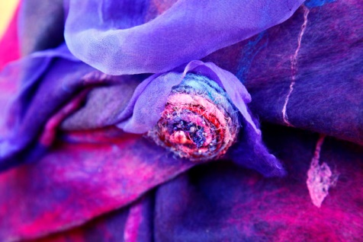
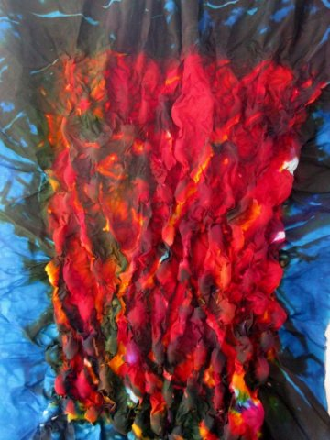
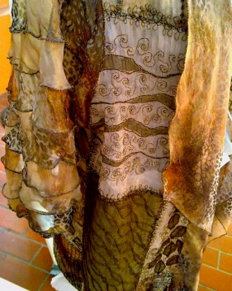
From wearables
(left to right)
Diana Booth, Art Nouveau Wrap
Val James, Coat of Dreams
Barbara Schey, Literally

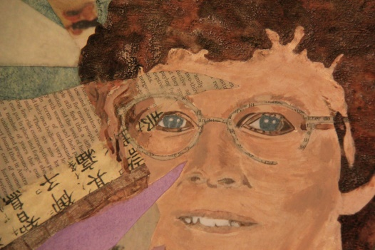
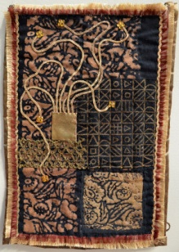
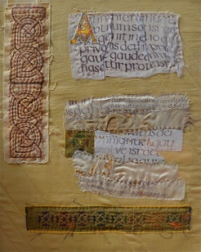
To telling stories and referencing history through imagery
Julie Richardson, A Portrait From 2 Perspectives
Diane Groenewegen, Pharaoh’s Flower
Bev Chow, Fragment of Text

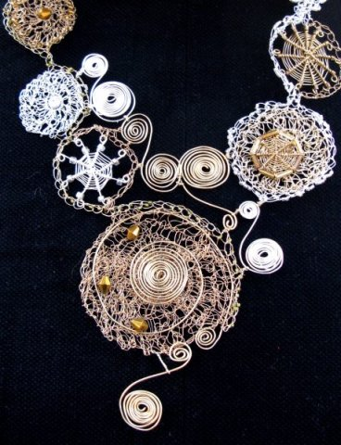
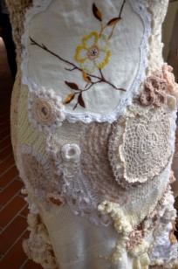
To highly textural works

Kay Murray, Be A Good Girl, 2012
Mary Hedges, The Silver Apple, 2008

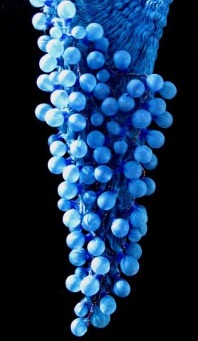
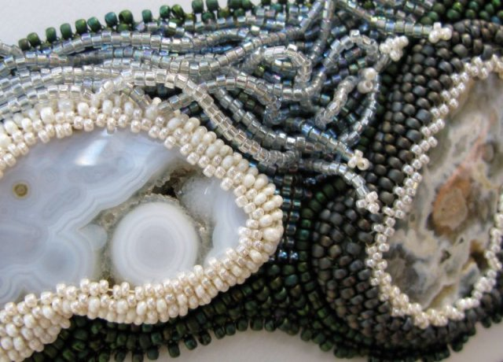
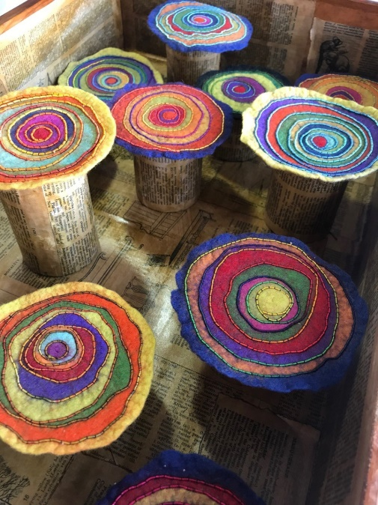
And 3 dimensional works

Fiona Hammond, Nature’s Treasures
Cathie Griffith, The Rings of their Years
Annette Brereton, Floating

Members use all manner of creative instincts, skills, talents and energy with colour, line and shape
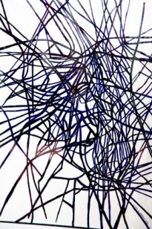
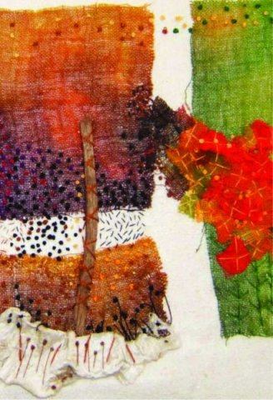
Maz Beeston, Fire Regrowth
Linda Baranov, Grass Forms 1

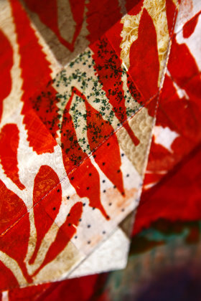

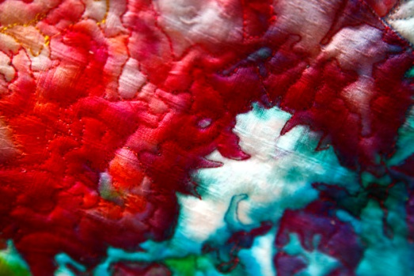
Linda Balding, Eye of the Soul
Robyn McGrath, Eruption in an Icy Land

What a powerful expression we have within our hands!

